A Quick Guide to

SCUT-COUCH Textline-NU

Version 1.0



Human-Computer Communication Intelligent Interface Lab.
South China University of Technology

http://www.hcii-lab.net/english/

1. Introduction
An unconstrained online handwritten Chinese text lines dataset, SCUT-COUCH Textline_NU (SCUT is the abbreviation of South China University of Technology, COUCH is the abbreviation of Comprehensive Online Unconstrained Chinese Handwriting, NU is the abbreviation of Nantes University, since part (17%) of the Textline dataset is collected in Nantes university, France), which is a subset of SCUT-COUCH, is built to facilitate the research of unconstrained online Chinese text recognition. Texts for handcopying are sampled from China People’s Daily corpus with a stratified random manner. To make the dataset more comprehensive, more representatives and more normalize. First, we divided the corpus into 7 subtopics: domestic news, international news, sports news, economic news, cultural news, academic trends, and education weekly. Second, used two representative collection tools: Touch screen LCD and Digital pen. Third, we carry out our sample collection work in two schools come from China and France. The current vision of SCUT-COUCH Textline_NU has 400 forms (for Digital pen only), 80 articles (for Touch screen LCD only) and 159,866 characters that are written by more than 157 participants under an unconstrained condition without preprinted character boxes.
2. Samples from SCUT-COUCH Textline_NU
One piece of handwriting samples collected by Digital pen is showed in figure 1.
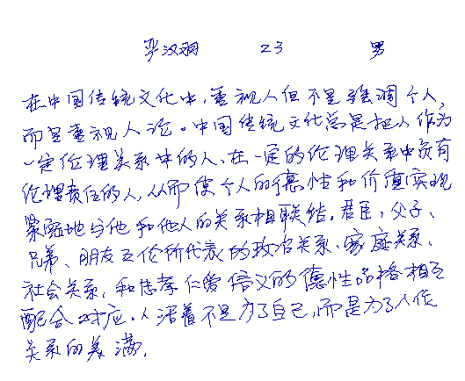
Figure 1. A digital pen sample.
Another piece of handwriting samples collected by touch screen LCD is showed in figure 2.
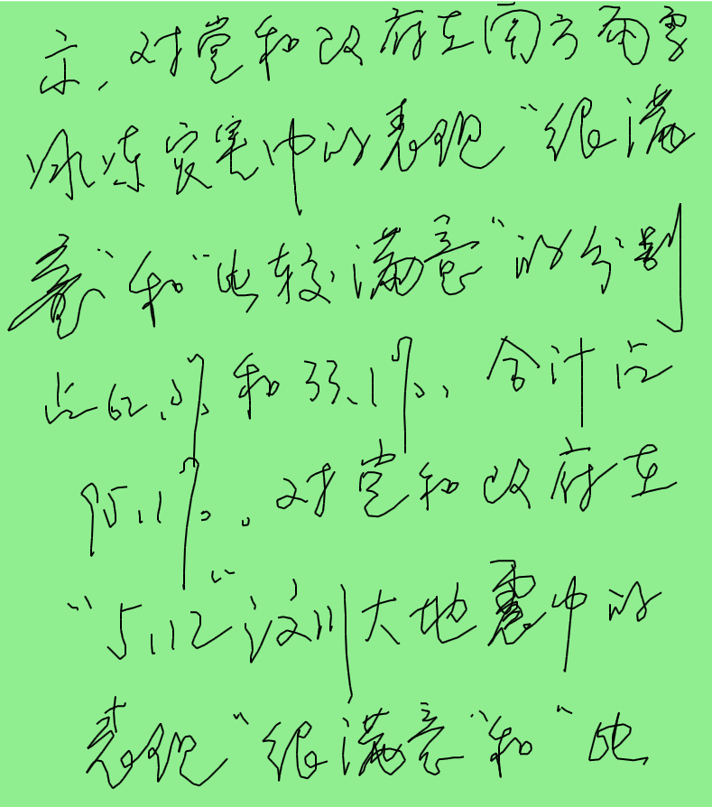
Figure 2. A touch screen LCD sample.

To design a text recognition system, many stages are involved. One of them consists in segmenting the text into lines. In this dataset, the ground truth will be given at the line level so that evaluation can be done independently of the line segmentation process. As shown in figure 1~2, all pieces of handwriting are based on paragraph or article. The illustration of line segmentation result is shown in figure 3.
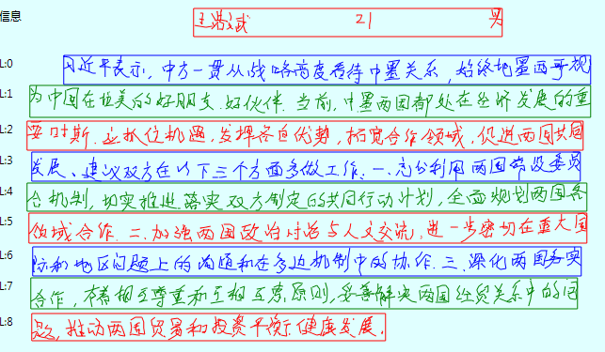
Figure 3. Line segmentation
3. Download of SCUT-COUCH Textline_NU
3.1 Download
The SCUT-COUCH Textline_NU Database can be downloaded freely at: http://www.hcii-lab.net/data/scutcouch/download/SCUT-COUCH2009-TextLine_NU.rar
All samples of SCUT-COUCH Textline_NU are storage by Unipen format. More information about the UNIPEN format could be found at: http://hwr.nici.kun.nl/unipen/unipen-history.html

A sample of unipen file:

.COORD X Y
.SEGMENT ? ? ? "江西省商务厅提供的数据显示，从2月1日" # The groundtruth text
.PAGE_SIZE 2100 2970
.PEN_DOWN # Stroke start
671 594
670 594
669 595
669 596
…
.PEN_UP # Stroke end
.PEN_DOWN
667 612
666 613
665 613
664 614
.PEN_UP
…

3.2 Directory structure
The SCUT-COUCH Textline_NU Dataset is divided into two directories: “Touch screen LCD” and “Digital Pen” which collected by Touch screen LCD and Digital Pen respectively. The storage structure database is illustrated in figure 4.
SCUT-COUCH Textline_NU Database
Touch screen LCD
Digital Pen
国内新闻
Domestic news
……
……
Writer01
Writer10
Domestic_01_01.unp
Domestic_01_01.unp
……
Domestic_01_01.unp
……
Domestic_01_01.unp
Writer01
Writer10
Domestic_01_01.unp
……
Domestic_01_01.unp
……
Domestic_01_01.unp
Domestic_01_01.unp
Writer01
Writer10
Domestic_01_01.unp
……
Domestic_01_01.unp
……
Domestic_01_01.unp
Domestic_01_01.unp
……
……
国内新闻
Domestic news
国内新闻
Domestic news
Figure 4. Directory structure of SCUT-COUCH Textline_NU

4. COUCH-TL Viewer V1.1
COUCH-TL Viewer version 1.1 is designed for viewing and modifying the SCUT-COUCH Textline_NU Dataset. It is a VS2008 C#-WPF project; so before running the program, please make sure the .Net framework environment has been installed in you computer.
4.1 How to open an unp file?
- Double click “COUCH-TL Viewer.exe”to execute the program. The main interface is showed as bellow:
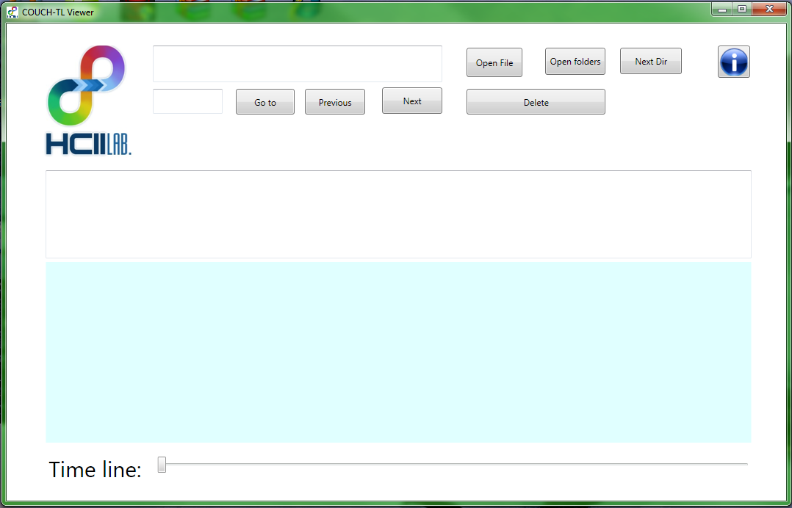
- Click“Open file”button to select a file you want to open.
If the file has been open successfully:
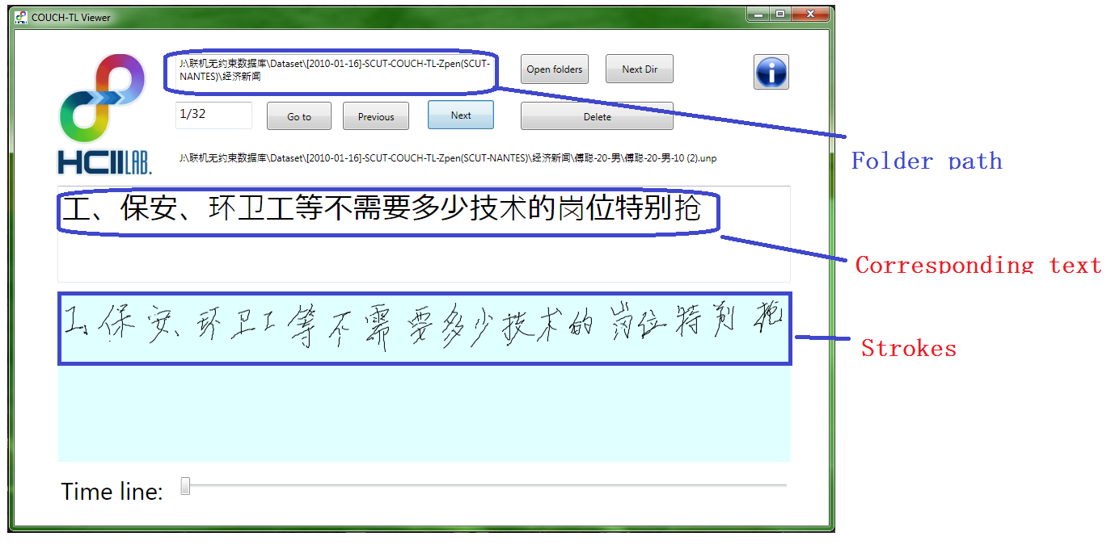
Then you can browse the next file in the same folder use “Next” button or previous use “Previous” button.
4.2 How to open a folder?
To open folders, you can click “Open folders” button to select a folder. The folder you select should be one-level or two-level folder; if the folder you select is a two-level folder, then you can use “Next dir” to browse the next subfolder.
A sample of two-level folder:

./Topic1/
./Topic1/Writer1/
./Topic1/Writer1/001.unp
./Topic1/Writer1/002.unp
...
./Topic1/Writer2/
./Topic1/Writer2/001.unp
./Topic1/Writer2/002.unp
...

4.3 How to modify a sample?
1) To modify the corresponding text: edit the text at “corresponding text box”; the file will save automatic.
2) To delete some strokes: you can use your mouse to select the strokes you want to delete, then click “Delete” button to delete. Be carefully, this operation can not be restored.
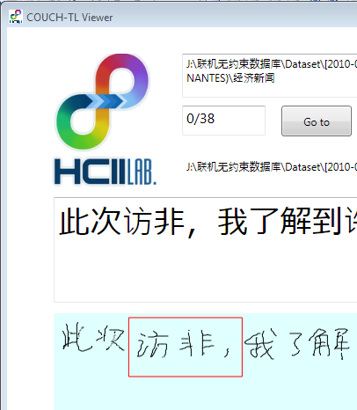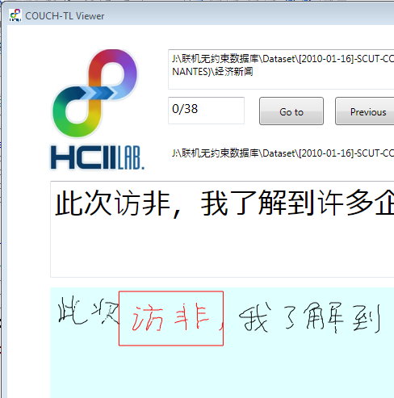

4.4 Functions of COUCH-TL Viewer V1.1:

Button name | Shortcut key | Icon | Functions description
Open file |  |  | Open a unp file.
Open folders |  |  | Open folders, the folder can be one-level or two-level folder.
Next folder |  |  | If the folder you opened is two-level folders, you can browse next subfolder by clicking this button.
Go to |  |  | Go to the file in current folder by index number.
Previous | Left |  | Previous file in current folder.
Next | Right |  | Next file in current folder.
Delete | Delete |  | Delete the selected strokes.
Time line |  |  | To drag the “Time line” slider, you can look over the order of strokes.
Information |  |  | Visit our website to get more information or download our dataset.

5. Copyright
All rights are reserved by HCII lab, SCUT. If you have any other questions or suggestions, please feel free to send email to us (lianwen.jin@gmail.com). The SCUT-COUCH Textline_NU database is public free to the academic community for research purpose usage. You should fill in a letter of commitment and send it via email to us (lianwen.jin@gmail.com). We will give you the decompression password to access the database after your letter has been received and approved.

Acknowledgments
1) We would like to thank Dapeng Tao, Huaide Zhan, etc. for helping to supervise data collection. We would also like to thank all those warmly cooperative volunteers.

2) This work is supported in part by the research funding of NSFC (no. U0735004, 60772216) and GDNSF (no. 07118074) and from Atlanstic/University of Nantes.
Versions of this manual
2010-04-29: version1.0 is released

